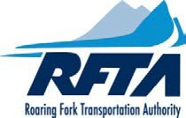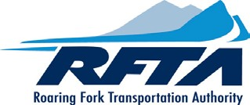

FREE SENIOR ID PASS - ORDER FORM
Seniors 65+ ride free
Instructions: A valid Photo ID must be shown to prove age. If you are 65+, Please enter your personal information below and submit a photo for your Senior ID pass.
NOTE: A photo is required. Submit photo from a camera or smart phone (a clear face shot is needed). Your full face must be visable or a new photo may be requested.
A completed order form is required to process your order.
Today's date:
Date of Birth:
Name:
Local Mailing
Address:
City: |  | State:
Phone:
(Optional) Email:
Notes:
PASS ORDER INFORMATION
* Please allow 7 to 10 business days to process.

Submit Completed form and photo to RFTA using one of the options below:
1. Email to: passorders@rfta.com
- Walk-in: Rubey Park Transit Center, 450 East Durant Ave Aspen, CO.
81611
- Walk-In: FTA FINANCE, 0766 INDUSTRY WAY, CARBONDALE, CO. 81623

For questions regarding this form, please email passorders@rfta.com

